Achieve function *double Power*

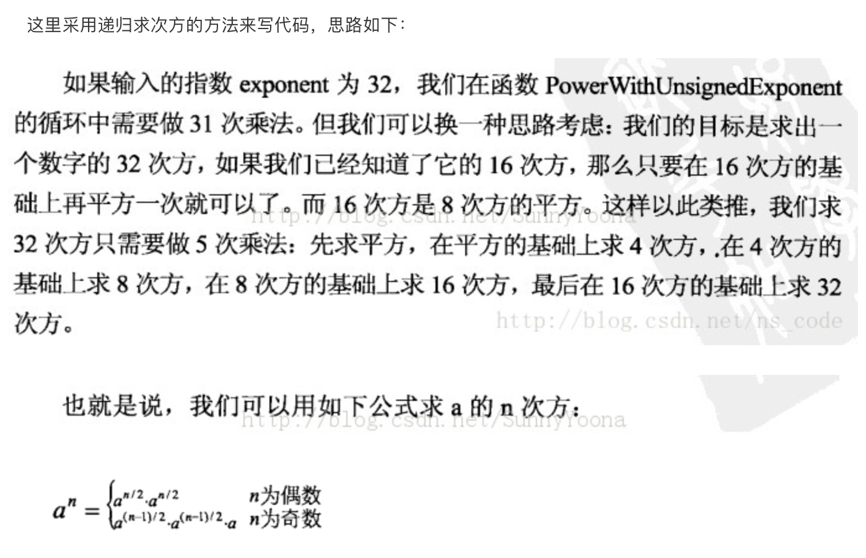

#include<stdio.h>

#include<math.h>

#include<stdbool.h>

bool flag = true;

//求base的正数absExp次幂

double PowerAbs(double base,unsigned int absExp)

{

//递归退出的条件

if(absExp == 0)

return 1.0;

if(absExp == 1)

return base;

//递归求次方

double result = PowerAbs(base,absExp>>1);

result \*= result;

//判断奇偶性

if(absExp&1 == 1)

result \*= base;

return result;

}

//求base的exp次方

double Power(double base,int exp)

{

//底数为0，指数为负数的情况

if(fabs(base-0.0)<0.0000001 && exp<=0)

{

flag = false;

return 0.0;

}

unsigned int absExp = (unsigned int)abs(exp);

double result = PowerAbs(base,absExp);

if(exp<0)

result = 1.0/result;

return result;

}

int main()

{

int n,exp;

double base;

while(scanf("%d",&n) != EOF)

{

int i;

for(i=0;i<n;i++)

{

//每次都要先将flag置为true

flag = true;

scanf("%lf %d",&base,&exp);

double result = Power(base,exp);

if(flag)

printf("%.2ef\n",result);

else

printf("INF\n");

}

}

return 0;

}